Website Performance Report

Website report for (month, year)

Pages Submitted to Search Engines
- http://www.URLaddress.com
- http://www. URLaddress.com

All optimized pages were submitted throughout the course of the previous month.

Top 5 Search Terms

- search term
- search term
- search term
- search term
- search term

Newly Optimized Pages
  - (page title, page URL)
  - (page title, page URL)

New Pages Added to the Site
  - (page title, page URL)
  - (page title, page URL)

Areas Identified for Improvement

Continue to improve page optimization and submission.

Results From Keyword Search (top 50 Results)

2 out of 10 visitors for search engines find your site through the Google.

The site is indexed for a selection of site pages. However, with a little more effort and more time, the site should gradually appear under the optimized keywords.

The site can be currently found under very specific terms such as (search term).

Most Popular Pages

- index.html
- price.html
- location.html

Site Statistics
- 739 unique visitors

- 23.83 visitors on average per day

- Total visits this month is a much more accurate total to the amount of traffic the site is receiving. We can now use this figure to monitor any changes in traffic.

Monthly Record of Site Visits

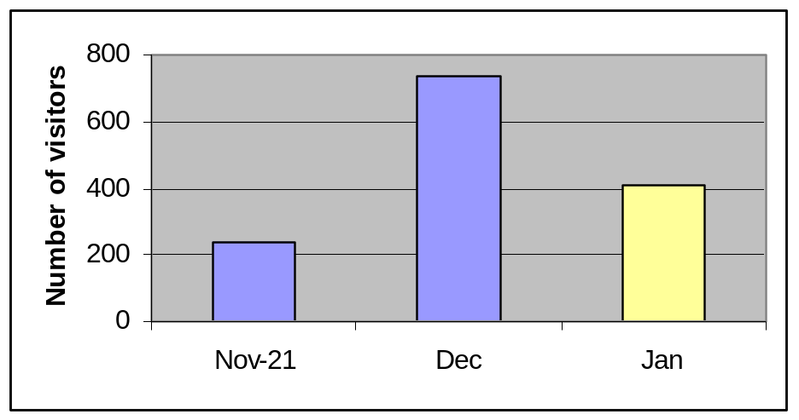

General Comments

Hello (client name),

The site continues to increase in visitor numbers and sales. The statistic package has kicked in and we will now be able to monitor the traffic totals more effectively.

Time and persistence will be the key to high ranking for the site. We will continue to optimize pages, and submit them to the search engines, in an effort to have the site ranking under more key words.

To aid this process, I would recommend the addition of some new/fresh content on certain pages. We will implement this strategy for the next report. The additional content will help optimization.

Regards,

Name
Title

Important Information
Please feel free to email me at any time in regards to your Website or any changes you require at (email address), or call us at (Web development company name) on (phone number).

Signed:

Name:

Date:

